**VISVESVARAYA TECHNOLOGICAL UNIVERSITY**



Belagavi – 590018

**A Project Report on**

**IDENTIFYING DISEASES IN RICE CROPS USING IMAGE PROCESSING**

**Submitted by**

**NITHIN D SOUZA 4SN16CS726**

**SAPTHAMI 4SN16CS735**

**SPOORTHI JAIN 4SN16CS744**

**VIVEK K S 4SN16CS757**

**In partial fulfillment of the requirements for the degree of**

**BACHELOR OF ENGINEERING**

**IN**

**COMPUTER SCIENCE & ENGINEERING**

**Under the Guidance of**

**Mrs. RESHMA B**

**Assistant Professor**

**Department of Computer Science & Engineering**

**SRINIVAS INSTITUTE OF TECHNOLOGY**

**(NAAC ACCREDITED) MANGALURU - 574143, KARNATAKA.**

**2019 - 2020**



**SRINIVAS INSTITUTE OF TECHNOLOGY**

**(NAAC ACCREDITED)**

**MANGALURU - 574143, KARNATAKA. DEPARTMENT OF COMPUTER SCIENCE & ENGINEERING**

**CERTIFICATE**

*Certified that the project work entitled “****IDENTIFYING DISEASES IN RICE CROPS USING IMAGE PROCESSING”*** *is a bona fide work carried out by*

**NITHIN D SOUZA 4SN16CS726**

**SAPTHAMI 4SN16CS735**

**SPOORTHI JAIN 4SN16CS744**

**VIVEK K S 4SN16CS757**

*in partial fulfillment for the award of* ***BACHELOR OF ENGINEERING*** *in* ***COMPUTER SCIENCE & ENGINEERING*** *of the* ***VISVESVARAYA TECHNOLOGICAL UNIVERSITY, BELAGAVI*** *during the year 2019 – 2020. It is*

*certified that all corrections/suggestions indicated for Internal Assessment have been incorporated in the report deposited in the departmental library. The project report has been approved as it satisfies the academic requirements in respect of Project work prescribed for the Bachelor of Engineering Degree.*

|  |  |  |  |  |
| --- | --- | --- | --- | --- |
| **Mrs. Reshma B.** |  | **Dr. Shivakumar G. S.** |  | **Dr. Shrinivasa Mayya D.** |
| **Project Guide** |  | **Head of the Department** |  | **Principal** |

**Name of the Examiners Signature with Date 1.**

**2.**

**ABSTRACT**

Most of the farmers aren't in a situation to apply best amount of inputs to their plants that are critical for enhancing the production. They might not recognize the amount of fertilizer required for plants and for that reason it could cause inequitable use of fertilizer and also they might not have proper knowledge about which pesticide/insecticide to be used for the diseased crop. Hence the growth could be damaged. This project offers the information about the diseases in a rice crop and also specifies the pesticide to be used for that rice crop. The farmer takes the photograph of the diseased crop and uploads the image in app. Then the photo is further treated using Image Processing Techniques and the disorder in the rice crop is classified. The data about the disorder and the name of pesticide/insecticide for use to cure the disease are sent to the farmer and the farmer can view the facts in his application. This may also attain benefits in controlling massive region of crops, and therefore frequently locates the signs and syndromes of disorders as quickly as they seem on rice crops.

**ACKNOWLEDGEMENT**

The success and final outcome of this project required a lot of guidance and assistance from many people and we are extremely fortunate to have got their support all along the completion of our project.

We take this opportunity to express our profound gratitude and deep regards to our Project Guide **Mrs. Reshma B.,** Assistant Professor, Department of Computer Science and Engineering, for her exemplary guidance, monitoring and constant encouragement throughout the course of this project.

We are highly grateful and would like to express our wholehearted thankfulness to our Project Coordinator, **Mr. Manjesh R.**, Assistant Professor, Department of Computer Science and Engineering, who has been our source of inspiration. He has communicated various ideas for improving the project and has been especially enthusiastic in giving his opinions and critical reviews in a constructive manner. We will remember his contribution forever.

We express a deep sense of gratitude to **Dr. Shivakumar G. S.**, Head of the Department, Computer Science and Engineering, for his cordial support, valuable information and guidance, which helped us in completing this project through various stages.

We also express our heartfelt gratitude to our Principal **Dr. Shrinivasa Mayya D.** for his kind co-operation and encouragement which helped us in the completion of this project.

We also thank our **Management** who helped us directly and indirectly for the successful completion of our project.

We are thankful to and fortunate enough to get constant encouragement, support and guidance from all the **Teaching and Non-teaching staff** of Department of Computer Science and Engineering who helped us in successfully completing our project.

Lastly, we would like to thank our **Parents** for their moral support and our Friends with whom we shared our day-to-day experiences and received lots of suggestions that improved our quality of work.

* Nithin D Souza
* Sapthami
* Spoorthi Jain
* Vivek K S

TABLE OF CONTENTS

|  |  |  |  |  |  |
| --- | --- | --- | --- | --- | --- |
| **CHAPTERNo.** | | **TITLE** | | | **PAGE No.** |
| **1** |  |  | **INTRODUCTION** | **1** | | |
|  | 1.1 |  | Problem Statement | 1 | | |
|  | 1.2 |  | Existing System | 1 | | |
|  | 1.3 |  | Proposed System | 2 | | |
|  | 1.4 |  | Objective | 2 | | |
| **2** |  |  | **LITERATURE SURVEY** | **3** | | |
| **3** |  |  | **SOFTWARE REQUIREMENT ANALYSIS** | **6** | | |
|  | 3.1 |  | Feasibility Study | 6 | | |
|  | 3.1.1 |  | Technical Feasibility | 6 | | |
|  | 3.1.2 |  | Operational Feasibility | 7 | | |
|  | 3.1.3 |  | Economic Feasibility | 7 | | |
| **4** |  |  | **SYSTEM REQUIREMENTSPECIFICATION** | **8** | | |
|  | 4.1 |  | Functional Overview | 8 | | |
|  | 4.2 |  | Operating Environment | 8 | | |
|  | 4.2.1 |  | Software Requirements | 8 | | |
|  | 4.2.2 |  | Hardware Requirements | 9 | | |
|  | 4.3 |  | Functional Requirements | 9 | | |
|  | 4.4 |  | Non-functional Requirements | 9 | | |
|  | 4.5 |  | Performance Requirements | 10 | | |
| **5** |  |  | **SYSTEM DESIGN** | **11** | | |
|  | 5.1 |  | High Level Design | 11 | | |
|  | 5.2 |  | Detailed Design | 12 | | |
|  | 5.2.1 |  | Use Case Diagram of Identifying Diseases In Rice Crops using Image Processing | 12 | | |
|  | 5.2.2 |  | Data Flow Diagram of Identifying Diseases In Rice Crops using Image Processing | 13 | | |
|  | 5.2.3 |  | Sequence Diagram of Identifying Diseases In Rice Crops using Image Processing | 15 | | |
| **6** |  |  | **SYSTEM IMPLEMENTATION** | **16** | | |
|  | 6.1 |  | Methods for Identifying Diseases In Rice Crops | 17 | | |
|  | 6.2 |  | Procedure for Identifying Diseases In Rice Crops | 18 | | |
|  | 6.2.1 |  | Procedure for Image Pre-Processing | 18 | | |
|  | 6.2.2 |  | Procedure Color Co-occurrence Method | 19 | | |
|  | 6.2.3 |  | Procedure for Rice Crop Disease Recognition in Non-Real time | 19 | | |
|  | 6.2.4 |  | Procedure for Rice Crop Disease Recognition in Real time | 19 | | |
|  | 6.3 |  | Flowchart for Identifying Diseases In Rice Crops using Image processing | 20 | | |
| **7** |  |  | **TESTING** | **21** | | |
|  | 7.1 |  | Testing Methodologies | 21 | | |
|  | 7.2 |  | Testing Criteria | 22 | | |
| **8** |  |  | **SCREENSHOTS** | **23** | | |
|  | 8.1 |  | Home Page | 23 | | |
|  | 8.2 |  | Image Selection | 23 | | |
|  | 8.3 |  | Pre-processing of Image | 25 | | |
|  | 8.4 |  | Segmentation of Image | 25 | | |
|  | 8.5 |  | Result of Rice Crop Leaves | 26 | | |
|  | 8.6 |  | Android App to Upload Images | 27 | | |
|  | 8.7 |  | Uploaded Image Accessed using Google Fire Base | 27 | | |
| **9** |  |  | **RESULT ANALYSIS** | **28** | | |
| **10** |  |  | **USER MANUAL** | **30** | | |
|  | 10.1 |  | Non-Real Time | 30 | | |
|  | 10.2 |  | Real Time | 30 | | |
|  |  |  | **CONCLUSION AND FUTURE WORK** | **31** | | |
|  |  |  | **REFERENCES** |  | | |
|  |  |  | **APPENDIX** |  | | |

|  |  |  |
| --- | --- | --- |
| **Figure No.** | **Figure Name** | **Page No.** |
| 5.1 | System Architecture of Identifying Diseases in Rice Crops using Image Processing | 11 |
| 5.2 | Use Case Diagram for Identifying Diseases in Rice Crops using Image Processing | 13 |
| 5.3 | Data Flow Diagram for Identifying Diseases in Rice Crops using Image Processing | 14 |
| 5.4 | Sequence Diagram of Identifying Diseases in Rice Crops using Image Processing | 15 |
| 6.1 | Flowchart for Identifying Diseases in Rice Crops using Image Processing | 20 |
| 8.1 | Home Page | 23 |
| 8.2 | Folder containing Image | 23 |
| 8.3 | Selection of Image | 24 |
| 8.4 | Loading of Image | 24 |
| 8.5 | Pre-processing of Rice Crop Image in Non-Real time | 25 |
| 8.6 | Segmentation of Rice Crop Image in Non-Real time | 25 |
| 8.7 | Result Page of Rice Crop Leaves using SVM in Non-Real time | 26 |
| 8.8 | Accuracy of the detected rice crop disease | 26 |
| 8.9 | Android app to upload images by the farmer | 27 |
| 8.10 | Uploaded images in Fire Base Console | 27 |

LIST OF FIGURES

**LIST OF TABLES**

|  |  |  |
| --- | --- | --- |
| **TABLE No.** | **TITLE** | **PAGE No.** |
| 7.1 | Test cases for Identifying Diseases in Rice Crops using Image Processing | 22 |
| 9.1 | Correlation Table | 28 |
| 9.2 | Result Analysis Table | 29 |



**Chapter 1**

**INTRODUCTION**

**CHAPTER 1**

**INTRODUCTION**

Image processing is a technique that carries out few functioning in an image, with a purpose to get an intensified picture or to take out some beneficial data from it. Arrival of latest automations which includes Digital Image Processing and Image Analysis Technology has many features within the biological science. About 78% of the farmers are minute and insignificant over the country and they may be negative in assets. Therefore, they may not be in a situation to use best quantity of inputs to their crops which are vital for increase in the production of crops. Most of the farmers might not have knowledge about how much amount of fertilizer are required and which pesticide/insecticide to be used to cure the diseased crop and accordingly it may result in inequitable use of fertilizer. Hence the expansion of crop gets damaged.

The farmer captures the photo of the diseased crop and uploads the photo in app. The photo is then treated using the Image Processing approaches and the disorder is observed. The facts of the disorder alongside with the name of pesticide/insecticide to be used are sent to the farmer and the farmer can view the information in his application. This may also attain benefits in controlling massive region of crops, and therefore frequently locates the signs and syndromes of disorders as quickly as they seem on rice crops.

**1.1 Problem Statement**

This project affords the data regarding the diseases in a rice crop and pesticides to be used for that particular rice crop. Image Processing Techniques are carried out at the uploaded photo to find the form of disease. Then the end result including the disease name and the name of fertilizers to be used is obtained. This outcome is then processed to a message surface in the server to notify the farmer about the disease. Now the farmer would be able to reclaim the entire data of the diseased crop in his application in orderly format.

* 1. **Existing System**

Recognition and categorization of disorder in rice crops in the early stages is one of the most necessary processes in agricultural environment. Due to the disorders in crops, it

will lead to more loss to economy of the farmers every year. Therefore, quick and precise detection of the disorder prevents the loss of production and also improves the grade of the production. As an outcome, it helps to the economic growth of the country. In regular practices, analysis of these disorders are based either on the visual indications caused by the pathogens or on the analysis of pathogens in the laboratory. The visual appraisal of the disease lesion is that it is subjective matter and it might fail to detect the disorder. On the contrary, pathogen identification in laboratory becomes an unmanageable process as it takes more time to proceed with pathogen classification which may fail to provide outcomes in appropriate time. In this procedure, automatic recognition accuracy was 58% in segmentation procedure and 63% manual segmentation approach. Due to poor capture condition, automatic technique will be failed. So to increase accuracy capturing condition should be very clear.

**1.3 Proposed System**

In the proposed system at the first stage photos of disordered crop are uploaded by the farmer. The photo is uploaded via the farmer is by choosing the right photo of the leaf preferably from the Choose File option in the android application. The photo uploaded via the farmer is then processed through MATLAB. Then the image-processing techniques are implemented and it extracts some useful features which can be used for future analysis. Few analytical approaches are used to categorize the photos to specify the problem. Then the disorder in the rice crop is noticed and later displayed using MATLAB. The pesticides for the recognized disease are entered into the database. The farmer can know the facts that were uploaded by the system through the application in which the photo was loaded.

**1.4 Objective**

The objective of identifying diseases in rice crops using image processing is to get a photograph by farmer of the infected rice crop ideally on the leaves. Then the picture is processed using image-processing approach and the sort of disorder is noticed. The name of the disease found in the disordered rice crop and the fertilizer or the pesticide/insecticide to be used is determined. These facts are updated on the application to notify the farmer about the disorder in rice crop. The farmer can see the outcomes and then apply them accordingly to the rice crop.



## Chapter 2

**LITERATURE SURVEY**

CHAPTER 2

**LITERATURE SURVEY**

1. **Automatic rice leaf disease segmentation using image processing techniques** Agriculture production is mainly dependent on economy of our country. Hence, prediction of disease plays an essential part in cultivation sector. The technique is targeted on the computerized detection procedure for segmentation of photograph on rice leaves under vast variety of environmental situation for further investigation. Various modern techniques for classifications and segmentation of image, algorithms have been studied and a mechanized detection technique has been presented for figuring out the precised disorders in leaves of rice crop under distinct environmental situation. Image processing methods had been broadly utilized in cultivation for recognition of sickness in plants. Then the pictures of infected plants are processed further through machine vision to forecast the disorder. MATLAB is software that is used to research picture presented for predicting the ailment in rice crop through the pictures of leaf.
2. **Paddy Leaf Disease Detection Using Image Processing and Machine Learning** In the recent years, the wide growth of plant virus and disorders has dramatically increased. Plant pathogens can be affected by fungal, bacterial, viral or nematodes and therefore can damage plant elements over or underneath the earth. Recognizing the symptoms and understanding how to successfully manipulate sicknesses is pivotal. The process is based on the idea of leaf detection using rice leaf photos. Paddy leaves may be infected by the disorders at uncertain period of growth and all over the rice crop. Hence, the image pre-processing and segmentation of image methods together with the different kinds of classification features such as SVM are used.
3. **Plant Infection Detection Using Image Processing**

Economy of a country depends on the agricultural production. Recognizing the disorders in crops is the main solution for preventing the mislaying in the agricultural production and to improve the grade of the agricultural product. The procedure is based on the mechanized detection of disorder in crops using Image Processing method. Algorithms used in image processing are advanced to discover the infection in plants or ailment through finding the shade feature in leaf areas. K means algorithm suggests set of rules for color segmentation and GLCM is used for detection of sickness.

1. **Detection and classification of rice plant diseases**

An original approach for recognizing and categorizing the disorders in rice crop is based on the picture of infected part in rice plants. Three types of rice crop illnesses specifically brown spot, bacterial leaf blight and leaf smut had been considered. To authorize precise extraction of features in rice plant leaves, a K-means clustering algorithm for segmentation of image of disordered part of a rice crop were used. The outcomes of K- means clustering algorithm, by eliminating the green pixels inside the disordered component have been enhanced. The different features under three categories that are color, shape, and texture were extracted. Support Vector Machine (SVM) technique for multi class categorization has also been used.

1. **Measurement of Disease Severity of Rice Crop Using Machine Learning and Computational Intelligence**

The process was directed to build an original approach that figure out the hardness of sicknesses that is found in the paddy crops by using machine learning techniques and artificial intelligence. The indication of paddy crop sicknesses implies the severity about the sickness and suggests choosing the first class technique to coping with the ailment. Most of the disorders in paddy plants look as a spot on its leaves. This can be analyzed by focusing on the disordered area, with the perfect amount and awareness of insecticide to be used to cure the disorder. K- Means segmentation approach were used to rate the degree of ailment severity in the paddy leaves.

1. **Identification of Diseases in Rice Plant using Back Propagation Artificial Neural Network**

The image processing component was built using MATLAB capabilities and it extracts strategies such as enhancement of image, segmentation of image and feature extraction, where four features are extracted to research the disorder such as part covered by the disorder on the rice crop, mean values for the R, G and B color of the disorder, standard deviation of the R, G and B of the sickness and mean values of the Hue, Saturation and Value of the sickness. To enhance the accuracy and performance of the image processing of rice crop, the Back Propagation Neural Network method was used.

1. **Rice Plant Disease Classification Using Transfer Learning Of Deep Convolution Neural Network**

The process has a machine learning approach on photo to recognize and categorize plant sickness. The photographs of the infected plant signs and indication in plant leaves and stems have been captured from the rice field. A pre-trained deep convolutional neural network (CNN) is used as a feature extractor and Support Vector Machine (SVM) as is used as classifier. The early recognition of rice sicknesses with the aid of this method could be used as a preventive the measure also as an early warning system. Further, it could be prolonged to increase a rice crop disorder categorization device on actual agricultural sectors.

1. **Digital image processing techniques for detecting, quantifying and classifying plant diseases**

The procedure give out an overview on approaches that use digital image processing methods to discover, evaluate and recognize crop disorders from digitized pictures. Although disorder signs can be observed in any part of the paddy plant, the approaches that check out visible indication in paddy leaves and stems have been observed. This became achieved for a prime reason: procedures take on with roots, plant seeds and fruits that have a few similarities that might cause a selected survey. The preferable suggestions, based on their objectives are further split into three classes: detection, severity quantification, and categorization.



## Chapter 3

**SOFTWARE REQUIREMENT ANALYSIS**

CHAPTER 3

**SOFTWARE REQUIREMENT ANALYSIS**

Software Requirement Analysis in the field of systems engineering and software engineering, surrounds those tasks which are used for finding out the necessity or conditions to meet for a new or adapted product or project, taking report of the perhaps contrary demands of the numerous shareholders, inspecting, reporting, authorizing and handling software or system requirements.

* 1. Feasibility Study

The main aim of the feasibility study is to deal with the technical, operational and economic feasibility of enlarging the application. Feasibility is the resolution to see in any case that the project is worth or not. The procedure obtained to do this resolution is called feasibility study. All systems are feasible, given limitless resources and boundless time. The feasibility study to be accompanied for this project involves:

* Technical Feasibility
* Operational Feasibility
* Economic Feasibility

3.1.1 Technical Feasibility

It is the degree of the certain technical solution and the accessibility of the technical resources and proficiency. It is one of the first studies that must be conducted after a project has been identified. A technical study of feasibility is a valuation of the logistical factors of business affair. This is considered with defining apparatus and software that strongly assure the requirement of user. The technical demands of the system might differ greatly but should add the provision to give output in a desired time, response time under satisfied states and the capability to proceed with a certain quantity of transaction at a certain speed.

The proposed system is created by using MATLAB software. MATLAB (Matrix Laboratory) is a multi-paradigm analytical measuring environment. It is an exclusive programming language developed by MathWorks, MATLAB permits matrix manipulations, scheming of data and functions, execution of set or procedures, forming of command line interfaces, and linking with the programs written in other languages

such as C, C++, C#, Java, Fortran and Python.

* + 1. Operational Feasibility

Operational feasibility is particularly worried with problems such as if it is developed and executed whether the system can be used, whether there is an opposition from the users that might influence the desirable benefits of the application. It has the potential to exercise, assist and accomplish the certain duties of a system or program. It includes all who designs, handles or utilizes the system. It is the estimation of how the proposed system reduces the issue and takes benefits of the events observed during the scope definition and problem analysis phases. This system contributes in various ways as it gives the details about the disorders in a rice crop and also pesticides to be used for that rice crop. Maintenance of the project is also uncomplicated and comprehensible and no crucial teaching and new expertise are needed.

* + 1. Economic Feasibility

Economic feasibility is the more often used approach for contrasting the success of the new system. Economic feasibility is the degree of the price effectiveness of an information system solution. Without a doubt, this action is most often and vital one of the three. Information structures are frequently seen as fund investments for the business, and also should be subjected to the identical kind of investment inspection as other fund investments. Economic analyses are adopted for estimating the success of the proposed system. In economic feasibility, valuable factor is cost benefit survey. This project is not economical, as it is highly depends on the system equipment that is not freely accessible.



## Chapter 4

**SYSTEM REQUIREMENT SPECIFICATION**

CHAPTER 4

**SYSTEM REQUIREMENT SPECIFICATION**

The main motive of System Requirement Specification is to express the schemes in the minds of a user into an official document. Through System Requirement Specification the user clearly describes what they expect from the system and the developer will clearly understands what are the capabilities required to build the system. It includes the element that defines the deliberate practicality needed by the customer. The motive of this documentation is to give out as an adviser to developers and testers who are responsible for the development of the system.

The project provides the information regarding the diseases in a rice crop. In regular practices, analysis of these diseases are based either on the visual indications caused by the pathogens or analysis of pathogens in the laboratory. The visual appraisal of the disease lesion is that it is subjective matter and may fail to detect the disease. It may fail to identify the sickness successfully in appropriate time. The farmer captures the photo of the infected crop and uploads the image through app. The photograph is then processed using the Image Processing methods and the disorder is observed.

* 1. Functional Overview
* User needs to input the leaf that is to be fed for preprocessing.
* An algorithm is used for clustering the processed image.
* The details of the disease name together with the name of pesticide/insecticide to be used are sent to the user and user can view the details about the infected crop in his application.
  1. Operating Environment

Operating environment involves minimum software and hardware requirements required by the system.

4.2.1 Software Requirements

* Operating System : Windows 7 or above
* Tools used : MATLAB 16.0 or above, NetBeans IDE 8.2, MySQL

Workbench 8.0/ MySQL Server 8.0, JDK 1.5.

* Programming Language : MATLAB Scripting Language, Java.
  + 1. Hardware Requirements
* Processor : Pentium 4 or above
* RAM : 8GB or above
* Hard Disk : 100GB or above
* Input device : Standard Keyboard and Mouse.
* Output device : V High Resolution Monitor, Mobile phone and IP Webcam.

4.3 Functional Requirements

Functional Requirements specifies the functionality of a system or its part. A function is defined as a set of inputs, behavior and outcomes. A functional requirement gives the results of a proposed system. Functional requirements urge the application architecture of a machine. Following are the functional requirements used in the project.

* Images can be processed in any required format i.e., jpg, png, bmp etc.
* Images are imported and stores image properties relating to the segmentation without manipulating the contents of the image.
* Image acquisition, image pre-processing, and image enhancement.
* Segmentation of image and feature extraction of the image.
* Recognition and categorization of crop disorder.

4.4 Non-Functional Requirements

Non-Functional requirement is a specification defines the standard, which can be used for judging the working of a system, instead of stating its behaviors. Non-Functional requirements are frequently known as standard attributes of a machine. The following are the non functional requirements of the application.

* Availability: The system will work as required according to the specified requirement.
* Reliability: The system has the ability to consistently perform the intended or required functions.
* Maintainability: The maintenance of a practical unit will be performed in accordance with the prescribed requirements.
* Accessibility: The System can be accessed by any appropriate users.
* Operability: The system has the ability to keep itself safe and reliable, according to predefined operational requirements.
* Usability: The system is ease of use and learnable by the users.
* Responsiveness: The system has ability to respond to the user very fast as soon as the input is fed.
* Cost: The machine is economically feasible.
  1. Performance Requirements

The project provides the information regarding the diseases in a rice crop. The outcome of the system consists of name of the disease and the name of pesticide to be used is retrieved. Thus, this application results in efficient usage of time. The proposed approach can detect the disease in rice crops. Using this approach, the rice crop sicknesses can be detected at the earlier stage itself and the pest control devices will be used to solve pest problems, decreasing risks to people and the surrounding. Interface is designed in such a way that user can understand very easily. Maintenance of the project is easy and understandable.



## Chapter 5

**SYSTEM DESIGN**

CHAPTER 5

**SYSTEM DESIGN**

The main motive of the scheme period is to frame a key of the issue described by the essential record. The scheme of a complex is probably the foremost analytic aspect influencing the standard of the software, and features a prime impression on the upcoming periods, distinctly evaluating and preservation. The outcome of this period is the scheme record. The scheme affair is usually parted into two distinct segments. They are system design and detailed layout.

* 1. High Level Design

High-level design also said to be system design, mainly focuses to recognize the modules that might be there in the machine, then the descriptions of each of these modules, and also how they communicate among themselves to get the needed outcomes. As an end result of system design, the entire main data structures, file patterns, outcome patterns and also the main modules within set-up and their descriptions are determined.

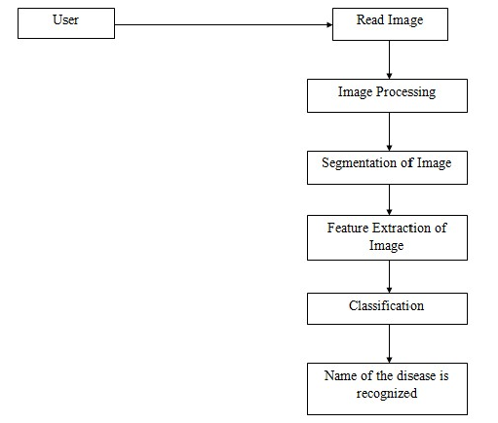

***Figure 5.1:*** *System Architecture of Identifying Diseases in Rice Crops Using Image Processing*

Figure 5.1 shows the system architecture of Identifying Diseases in Rice Crops using Image Processing. The user loads the picture of crop. The image is pre-processed. Segmentation of pre-processed image takes place. The Feature Extraction is done using GLCM where the different features of picture are extracted. The extracted picture is fed as input to the SVM Classifier to distinguish the kind of disease present in the crop.

* 1. Detailed Design

In this detailed scheme, the inner reasoning of each and every units laid out in complex pattern is set. Here an additional particular of the data structures and algorithmic scheme of each and every unit is stated. The reasoning of unit is typically laid out in a high-level scheme interpretation language as it is free of target language where the software will finally be executed.

5.2.1 Use Case Diagram of Identifying Diseases in Rice Crops Using Image Processing

A use case diagram in short is a description of a client’s communication with the machine and illustrating the statements of a use case. A use case diagram can render the various kinds of clients of a system and therefore the several procedures in which they communicate with the system. A use case representation may be a vital or behaviour diagram in UML. They are signified by either circles or ellipses. Use case figures pattern the capability of a machine using actors and use cases. Use cases are a group of steps, solutions, and tasks that the machine will have to execute. Use case diagrams are worthy for projecting the functional requirements of a machine which will interpret into pattern alternatives and evolution superiorities. Recognition of any inner or outer aspects which will govern the machine and then taken into consideration will also be done.

There is just one actor that’s user within the proposed system of Identifying Diseases in Rice Crops using SVM. The user reads the photo of crop that is to be classified. After reading the photograph, the system will load and pre-process the photo. The photo is clustered using k-means clustering algorithm by the system. The photo then undergoes segmentation. Then the system will extract the features contrast, entropy, energy, homogeneity, and correlation etc of the photograph using GLCM. The extracted features of the photo are processed into the SVM Classifier. The SVM Classifier will classify the name of disease present in the image. The user then gets the output which specifies the name of disease present in rice crop.

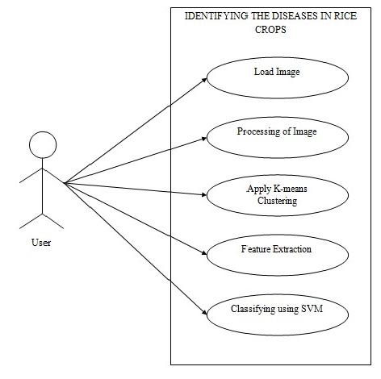

***Figure 5.2:*** *Use Case Diagram for Identifying Diseases in Rice Crops using Image Processing*

5.2.2 Data Flow Diagram of Identifying Diseases in Rice Crops using Image Processing

A Data Flow Diagram (DFD) is a graph displaying circulation of input values from their origin in items through procedures that convert them as targets in any other items. A DFD

is also referred to as “bubble chart” which in turn has the intent of explicating the

machine objectives and acknowledging main modifications which will be executed as programs in system design. Hence this is the initial step of the scheme phase that validly degrades the requirement objectives right down to the bottom level of particulars. The bubbles indicate input transformations and also the lines symbolize input flows within the device.

Figure 5.3 shows the data flow diagram for Identifying Diseases in Rice Crops using Image Processing. User can give input in the form of picture that is captured. The image actualization capture RGB image. Next Image Segmentation is done for that particular captured photograph. The photo obtained will extract the color features. This

extracted RGB picture is transformed to gray scale picture. The Feature Extraction is

done by GLCM (Gray Local Co-occurrence Matrix). The values which stored in database is considered and given input as SVM train. The input feature is also given to SVM. The condition of both test part and train part is inspected, one-to-one mapping is done. The

picture that doesn’t complement the process is further repeated.

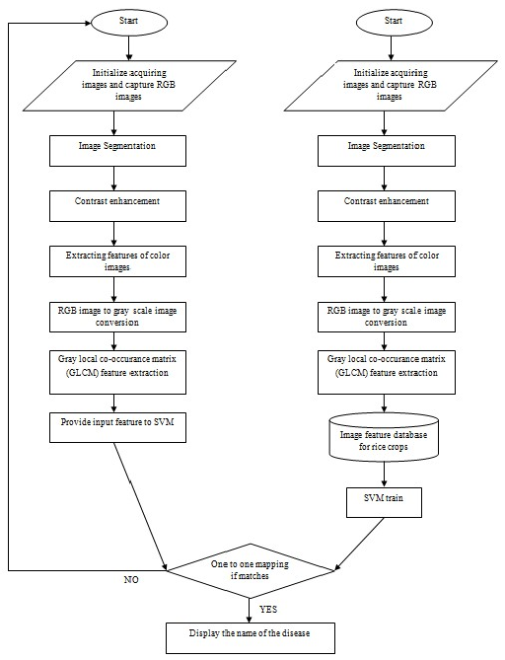

***Figure 5.3:*** *Data Flow Diagram for Identifying Diseases in Rice Crops using Image Processing*

* + 1. Sequence Diagram of Identifying Diseases in Rice Crops using Image Processing

Figure 5.4 shows the sequence diagram of Identifying Diseases in Rice Crops using

Image Processing. The user loads the picture and the application will preprocess the

picture. The preprocessed photo is segmented in the segmentation module. The features are then withdrawn from the segmented picture in the extraction phase. The segmented image is returned to the client.

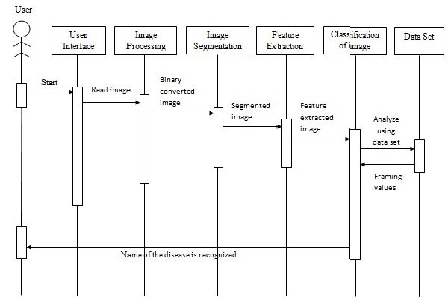

***Figure 5.4:*** *Sequence Diagram of Identifying Diseases in Rice Crops using Image Processing*



## Chapter 6

**SYSTEM IMPLEMENTATION**

CHAPTER 6

**SYSTEM IMPLEMENTATION**

System Implementation is the period where the conceptual layout is transformed to a functioning system. The new machine might be absolutely new, restoring a current manual, or automated device or it could be a chief variation to a current system. The system is applied using MATLAB and data set.

**MATLAB**

The title MATLAB symbolizes MATrix LABoratory. MATLAB is built at first to give uncomplicated approach to matrix software evolved by the LINPACK (linear system package) and EISPACK (Eigen system package) projects. MATAB is a top-execution language for high-tech computing.

It blends data processing, determination, and integrated development environment. Moreover, MATLAB is a latest programming language environment that has knowledgeable data structures, also built-in polishing and rectifying devices, and assist object-oriented programming. MATLAB has several profits against normal computer languages (e.g., C, FORTRAN) for resolving high-tech issues.

MATLAB is a communicative machine in which primary data item is an array for which dimensioning is not needed. The software bundle is buyable since 1984 and is currently known as a quality tool at many of the academies and corporations globally. MATLAB can be used for matrix estimations, evolving and handling algorithms, generating user interfaces (UI) and data resolution. The multi prototype arithmetical evaluating conditions will help creators to link with programs evolved using various languages that make it feasible to tackle the distinctive stability of specific language for distinct reasons.

MATLAB has been widely used by architects and technologists in various sectors like the image and the signal processing, the interactions, the sharp grid scheme, semi automatic as well as quantitative finance. The usage of graphics commands is uncomplicated that does the perception of outcomes right away accessible. Discrete approaches are gathered in bundles known as toolbox. Toolboxes also present for signal processing, prototype, streamlining and various sector of applied science and engineering.

**RiceCropExpert**

The current mobile App RiceCropExpert is developed for the farmers to provide information in real time about disease and its problems. The App has web based application devices that facilitates flow of details.

RiceCropExpert App offers a pretty straightforward and functional layout. The framework is effortless and there is other few options in the main menu, such as which camera to use. RiceCropExpert is an Android app that lets you transform pictures of rice crop disease taken by mobile camera into server where the identification of disease is carried out by experts.

* 1. **Methods for Identifying Diseases in Rice Crops**

**RGB**

RGB illustrates Red, Green and Blue color elements for every picture element which is also said to be true color image. RGB array is of class dual in which every color bit is a value that comes between 0 and 1. It can also be saved with the third proportion of given input array.

**K-Means Clustering**

The K-means clustering categorizes items by considering a batch of attributes into K number of classes. The categorization of item is completed by reducing the total of squares of the interval between the item and the related cluster.

**Color Histogram**

The aspects and conduct of image is controlled in color histogram. It turns color picture into HSV image and also conserves the hue and saturation modules. The values are taken out and framed in the graph. From the HSI image matrix, the severity matrix is acquired.

**Color Moments**

The main purpose of using color moments is for color indexing. It only reviews the starting three color bits as trademark in picture reviving approaches. It collates the two pictures on basis of color.

**HSV Feature**

The Hue Saturation Value (HSV) symbolizes the color, supremacy of color and glow. Accordingly, the color spotting algorithm can explore in terms of color spot and color clearness. Recognizing the pixels can also be done using HSV.

**SVM (Support Vector Machine)**

It is a supervised learning algorithm which is mainly helpful for binary categorization or regression. It is a mesh of discrete monitoring. It is on basis of resolution planes which distinguishes decision boundaries. It also separated the bundle of items having diverse class. The complex is built on two distinct conditions namely Real Time Crop and Non- Real Time Crop.

**Otsu Threshold Algorithm**

By fixing all pixels under few thresholds to zero and entire pixels over that threshold to one binary picture from grey-level photos have been built by thresholding. In accordance with threshold, it splits pixels into dual clusters. As a next step mean of all cluster has been found. Then square the difference between the means. Finally multiply the total count of pixels in one cluster times with the count in the other cluster times.

* 1. Procedure for Identifying Diseases in Rice Crops

Step 1: Start

Step 2: Image Acquisition Step 3: Image pre-processing Step 4: Image Segmentation

Step 5: Feature Extraction in Image Step 6: Classification using ANN

Step 7: Comparison and display the output Step 8: Stop

6.2.1 Procedure for Image Pre-Processing

Step 1: Start

Step 2: Transform initial picture to grey scale Step 3: Convert grey scale to binary image Step 4: Stop

* + 1. Procedure Color Co-occurrence Method

Step 1: Insert RGB picture.

Step 2: Transform to HSI for unique features extraction

$H=\{θ if B < G , 360- θ if B>G$

$$S=1-\{1/(R+G+B)\}[min(R,G,B)]$$

$I=1/(R+G+B)$

Step 3: Texture records estimation, the SGDM matrix is formed. Step 4: By using GLCM function, the attribute is evaluated.

* + 1. Procedure for Rice Crop Disease Recognition in Non-Real time

Step 1: Start

Step 2: Train the dataset by selecting feature extraction option. Step 3: Browse the image from dataset for testing.

Step 4: Select Pre-processing button to perform preprocessing of the selected rice crop image.

Step 5: Select Segmentation button to perform Segmentation of the selected rice crop image.

Step 6: Select Feature Extraction button to perform Extraction of features of the selected rice crop image.

Step 7: SVM algorithm is used for recognition. Step 8: End.

* + 1. Procedure for Rice Crop Disease Recognition in Real time

Step 1: Start

Step 2: If Camera is ON

Capture the rice crop image Upload the image to server

Pre-processing of captured rice crop image

Segmentation of captured crop image

Feature Extraction of captured rice crop image

Step 3: SVM algorithm is used for recognition.

Step 4: End

6.3 Flowchart for Processing

**Identifying Diseases in Rice Crops using Image**

A system flowchart typically reveals how data flows all over a system and how event controlling decisions are done. Initially the picture is input, and then pre-processing of the input picture takes place followed by segmentation. Later the photos are distinguished according to their extracted feature. Finally, the name of the rice crop disease is detected. The steps involved are shown in figure 6.1.

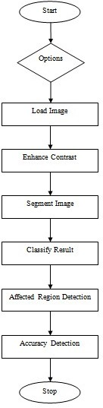

***Figure 6.1:*** *Flowchart for Rice crop disease Identification system using Image processing*



## Chapter 7

**TESTING**

CHAPTER 7

**TESTING**

Software testing is the procedure that helps to spot the precision, integrity, safety and standard of evolved computer software. This includes the procedure of accomplishing the solution or approach with the objective of locating faults. Standard is not perfect rather it is worth to few people. By having that in mind testing might not fully build the precision of unpredictable computer software. Testing also outfits a review or balancing that relates the condition and also conducts the outcome against a description.

Testing outlines the initial act in regulating the mistakes in a program. Without any doubt the success of testing in disclosing faults in programs counts badly on the test cases. Because code is the at most item that can be implemented and whose real ways can be found, testing is the period where the faults left from all the earlier period should be noticed.

The program that is to be tested is implemented with a collection of test cases. The outcome of the program for the test cases are calculated to find if the programming is accomplishing as anticipated.

* 1. Testing Methodologies

The following are the testing methodologies:

* **Unit Testing:** This is the initial period of testing; the various modules or elements are tested separately, frequently executed by coder himself.
* **Integration Testing:** In this kind of testing numerous unit tested modules are merged into subsystems, which might later be tested. The objective mainly is to view that modules could be merged correctly or not.
* **System Testing:** Here the whole software system is tested. The reference document for this procedure is the requirement specification and the objective is to view if the software satisfies the needs. This kind of testing is famously known as black box testing.
* **Acceptance Testing:** It is executed with logical facts of the user to exhibit that the software is functioning suitably. It is the test done to find if the needs of a specification are happened.
  1. Testing Criteria

***Table 7.1:*** *Test cases for Identifying Diseases in Rice Crops using Image Processing*

|  |  |  |  |  |
| --- | --- | --- | --- | --- |
| **Sl. No** | **Test Procedure** | **Pre-Condition** | **Expected Result** | **Passed/ failed** |
| 1 | Press on Load Image icon | Blank Image Preview | Selected image appears at image preview. | Passed |
| 2 | Press on enhance contrast icon | Selected Image Preview | Enhanced Image | Passed |
| 3 | Press on segment image icon | Enhanced Image | Diseased part of the rice crop leaf is selected | Passed |
| 4 | Press on Classification Result | Perform execution of algorithms | The name of the disease is displayed | Passed |
| 5 | Press on Accuracy in % | Pre-processing, Segmentation and Feature extraction is completed | The Accuracy in percentage is displayed | Passed |



## Chapter 8

**SCREENSHOTS**

CHAPTER 8

* 1. Home Page

**SCREENSHOTS**

The Figure 8.1 shows the homepage of the application. Processing of image is done in this page. It contains some information about the application such as pre-processing of image, segmenting the loaded image, type of disease detected using SVM and K-Means clustering method.

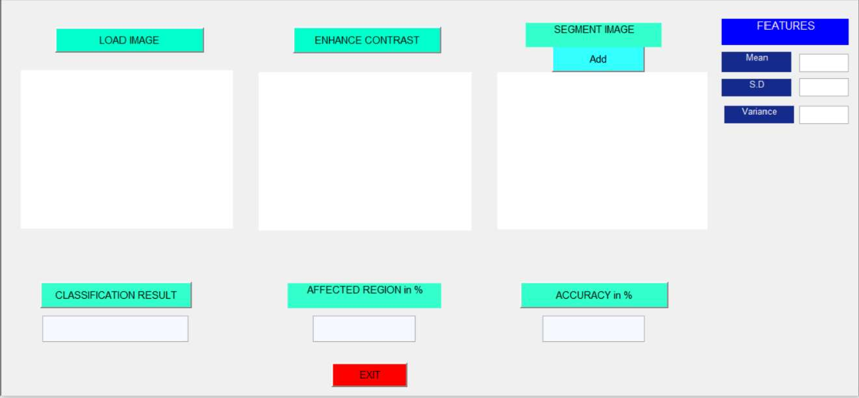

***Figure 8.1:*** *Home Page*

* 1. Image Selection

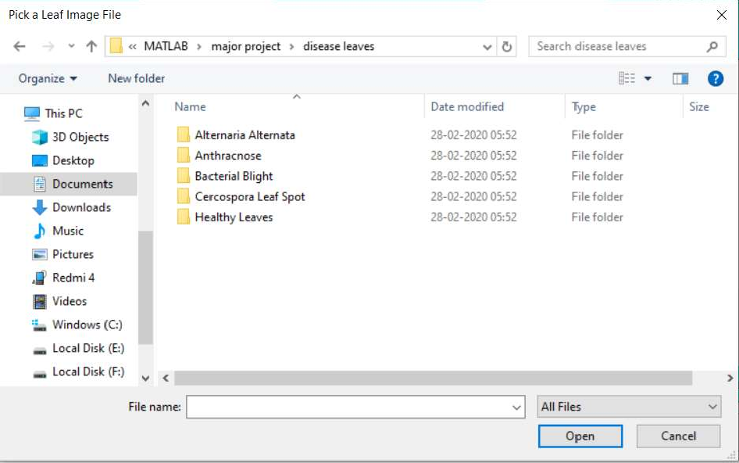

***Figure 8.2:*** *Folder containing Image*

The Figure 8.2 shows the folder having different type of rice crop images in it. Four types

of diseases in rice crops

can be seen. Also set of healthy leaves

are taken to check

whether there is disease in rice crop or not.

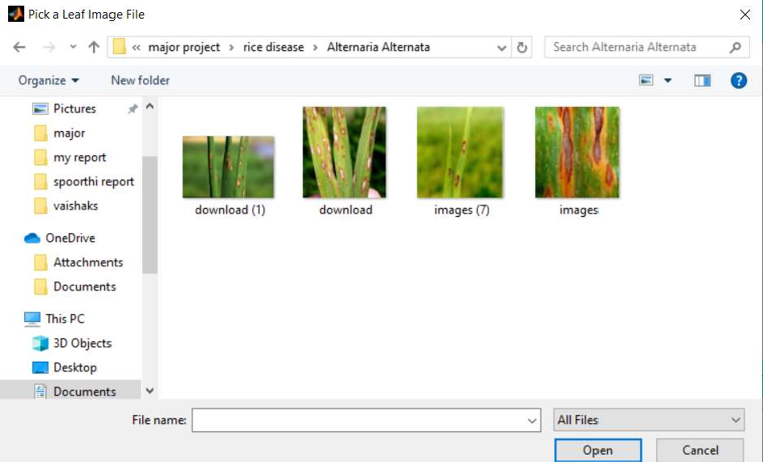

***Figure 8.3:*** *Selection of Image*

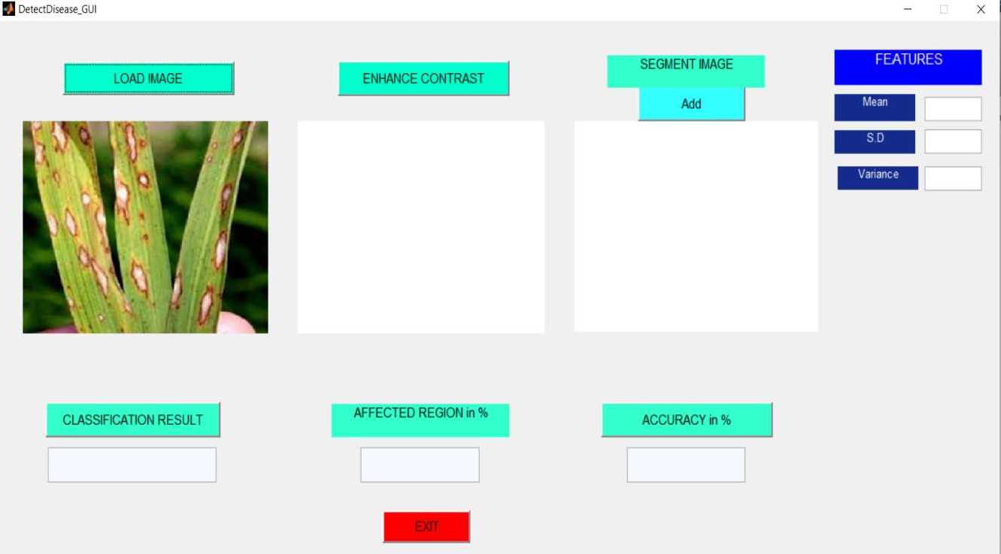Figure 8.3 shows the collection of different rice crop images. Here the user will select a particular image for the detection. The folder contains the images that are to be tested. The selected image will be displayed in the box provided in the homepage. The selected image can be used for predicting the further result.

***Figure 8.4:*** *Loading of Image*

Figure 8.4 shows the image being loaded of interest. The image will be loaded when the client selects the Browse Image option. The picture contains the leaf which needs to be tested and classified will be loaded here. The selected image will be displayed in the box provided in the homepage.

* 1. Pre-processing of Image

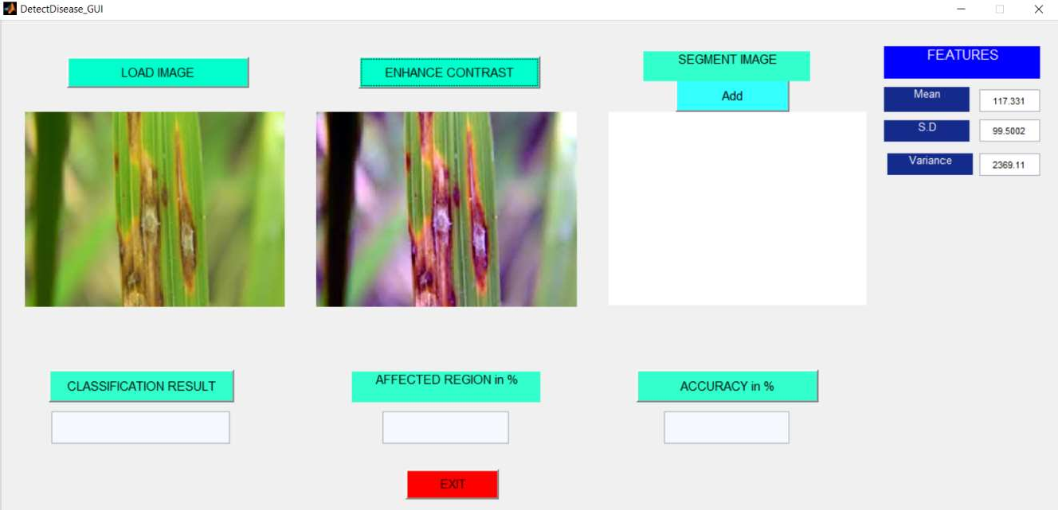

***Figure 8.5:*** *Pre-processing of Rice Crop Image in Non-Real time*

Figure 8.5 shows the images that being pre-processed. The image will be first converted from RGB to GRAY. This image will be converted to gray threshold. This gray threshold image gets converted to black and white. The loaded image gets converted from RGB to HSV.

* 1. Segmentation of Image

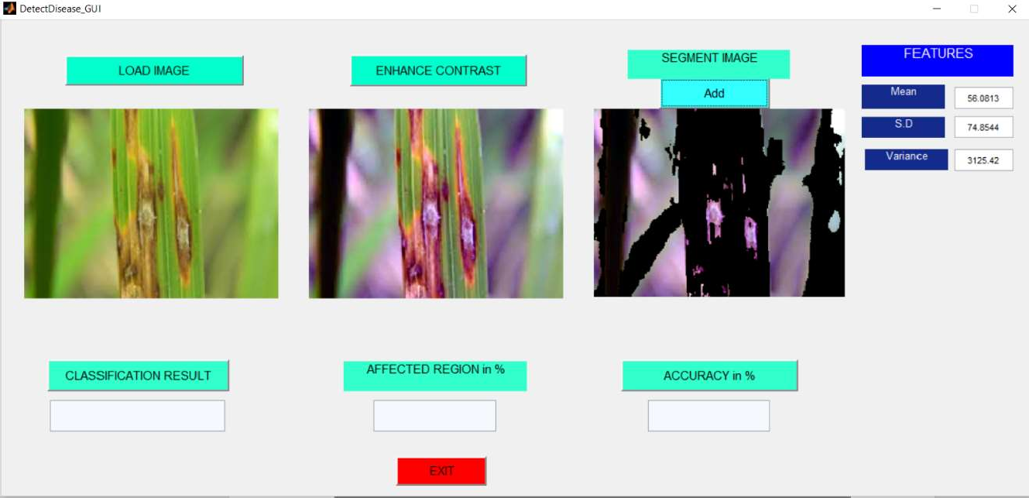

***Figure 8.6:*** *Segmentation of Rice Crop Image in Non-Real time*

The Figure 8.6 shows the segments of the loaded picture. Once the user loads the image, the user needs to click on Segmentation Image button to get the segments of the image.

The segmentation image clustering algorithm.

will be in three different clusters which

uses the K-means

* 1. Result of Rice Crop Leaves

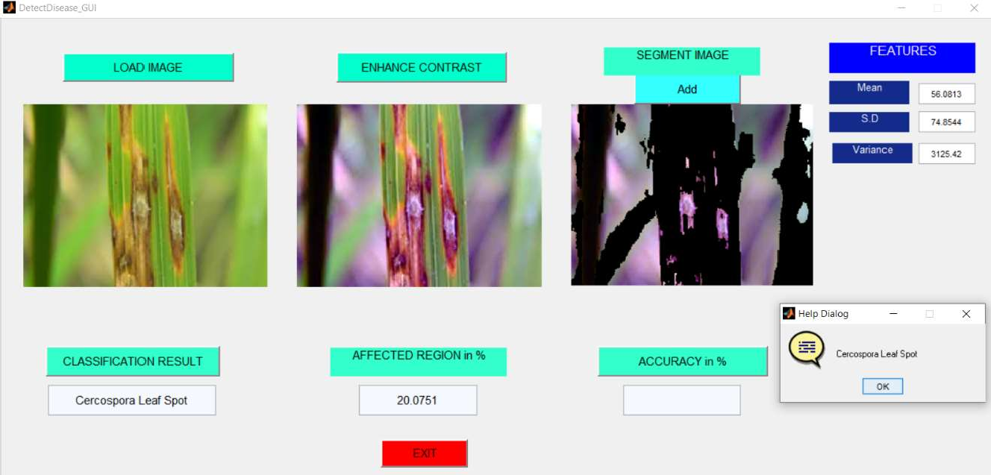

***Figure 8.7:*** *Result Page of Rice Crop Leaves using SVM in Non-Real time*

The Figure 8.7 shows Recognition of disease in rice crop leaves. This process uses SVM method for recognizing disease. After identifying the disease in leaf, the percentage of affected region is also known. The result will be displayed.

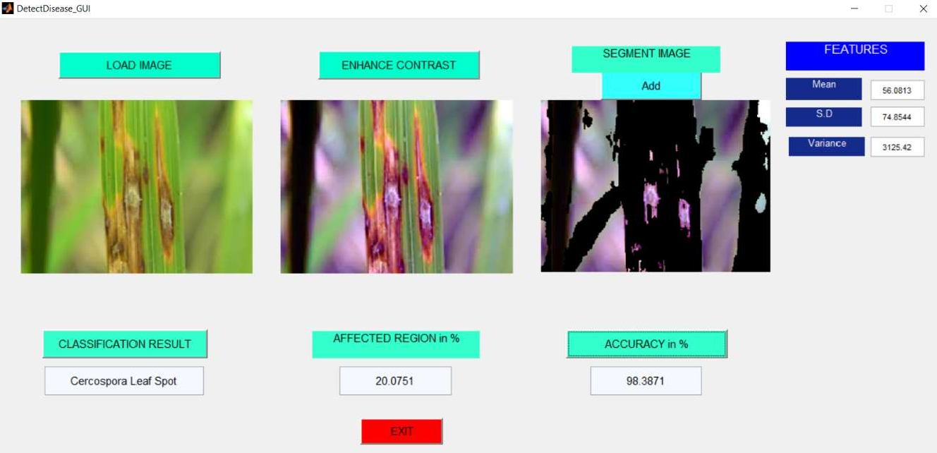

***Figure 8.8:*** *Accuracy of the detected rice crop disease*

The Figure 8.8 shows Accuracy of the detected rice crop disease. After identifying disease and the affected area of rice crop leaf in form of percentage, the accuracy will be displayed.

* 1. Android App to Upload Images

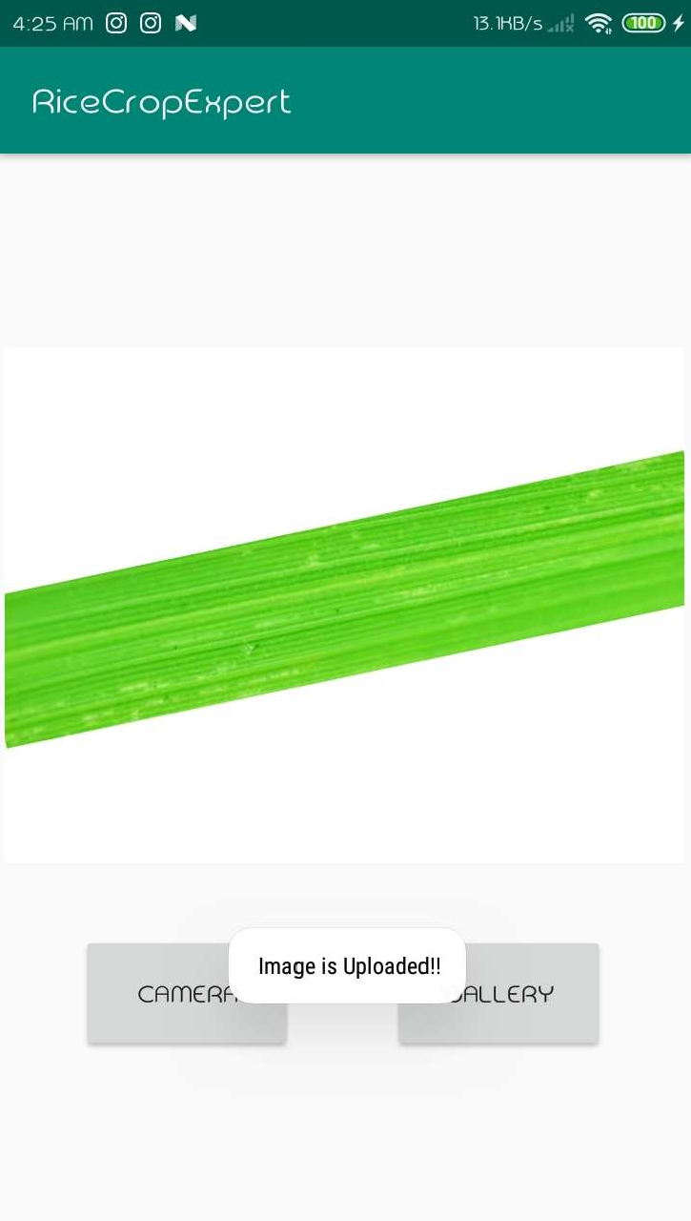

***Figure 8.9:*** *Android app to upload images by the farmer*

The Figure 8.9 shows image of android app to upload images. The farmer needs to click photo of rice crop to be uploaded by using camera or can upload the image directly from gallery. This image will be used for further analysis.

* 1. Uploaded Image Accessed using Google Fire Base

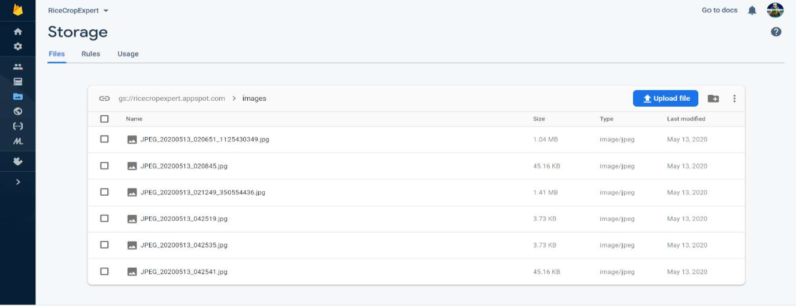

***Figure 8.10:*** *Uploaded images in Fire Base Console*

The Figure 8.10 shows the uploaded images in Fire Base Console. Fire Base stores

images that have been uploaded by farmers through dedicated app RiceCropExpert. The files can later be used for further analysis.



## Chapter 9

**RESULT ANALYSIS**

CHAPTER 9

**RESULT ANALYSIS**

A **true positive** trial outcome is one which reveals the state when the state is existing.

A **true negative** trial outcome is one that does not reveal the state missing.

when the state is

A **false positive** trial outcome is one which reveals the state when the state is missing.

A **false negative** trial outcome is one that does not reveal the state when the state is existing. Let TP mark the unit of true positives, TN the unit of true negatives, FP the unit of false positives, and FN the unit of false negatives.

**Sensitivity** monitors the capability of a trial to reveal the state when the state is existing. Accordingly, Sensitivity = TP / (TP+FN).

**Specificity** monitors the capability of a trial to precisely refuse the state (not reveal the state) when the state is missing. Accordingly, Specificity = TN / (TN+FP).

**Predictive value positive** is the share of positives that match to the existence of the state. Accordingly, Predictive value positive = TP / (TP+FP).

**Predictive value negative** is the share of negatives that match to the missing of the state. Accordingly, Predictive value negative = TN / (TN+FN).

**Accuracy =** TP+TN / (TP+TN+FP+FN).

***Table 9.1:*** *Correlation Table*

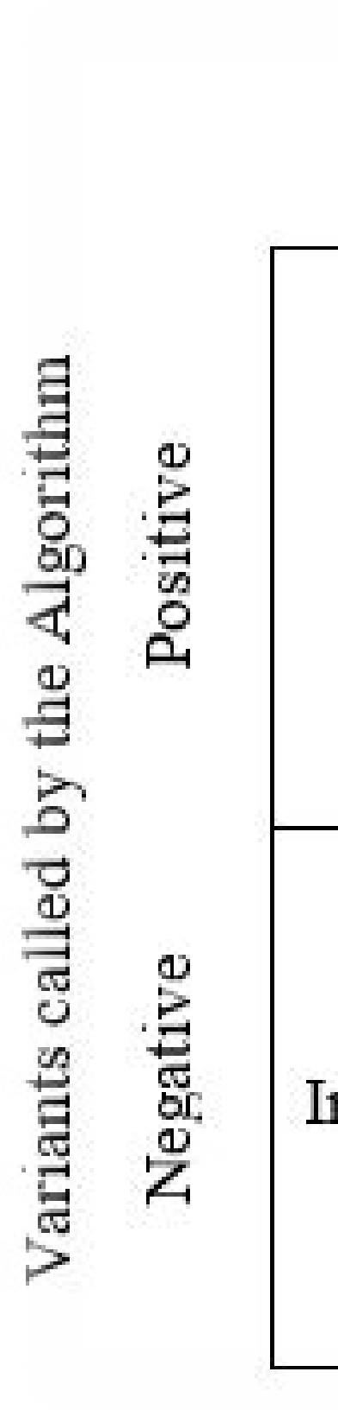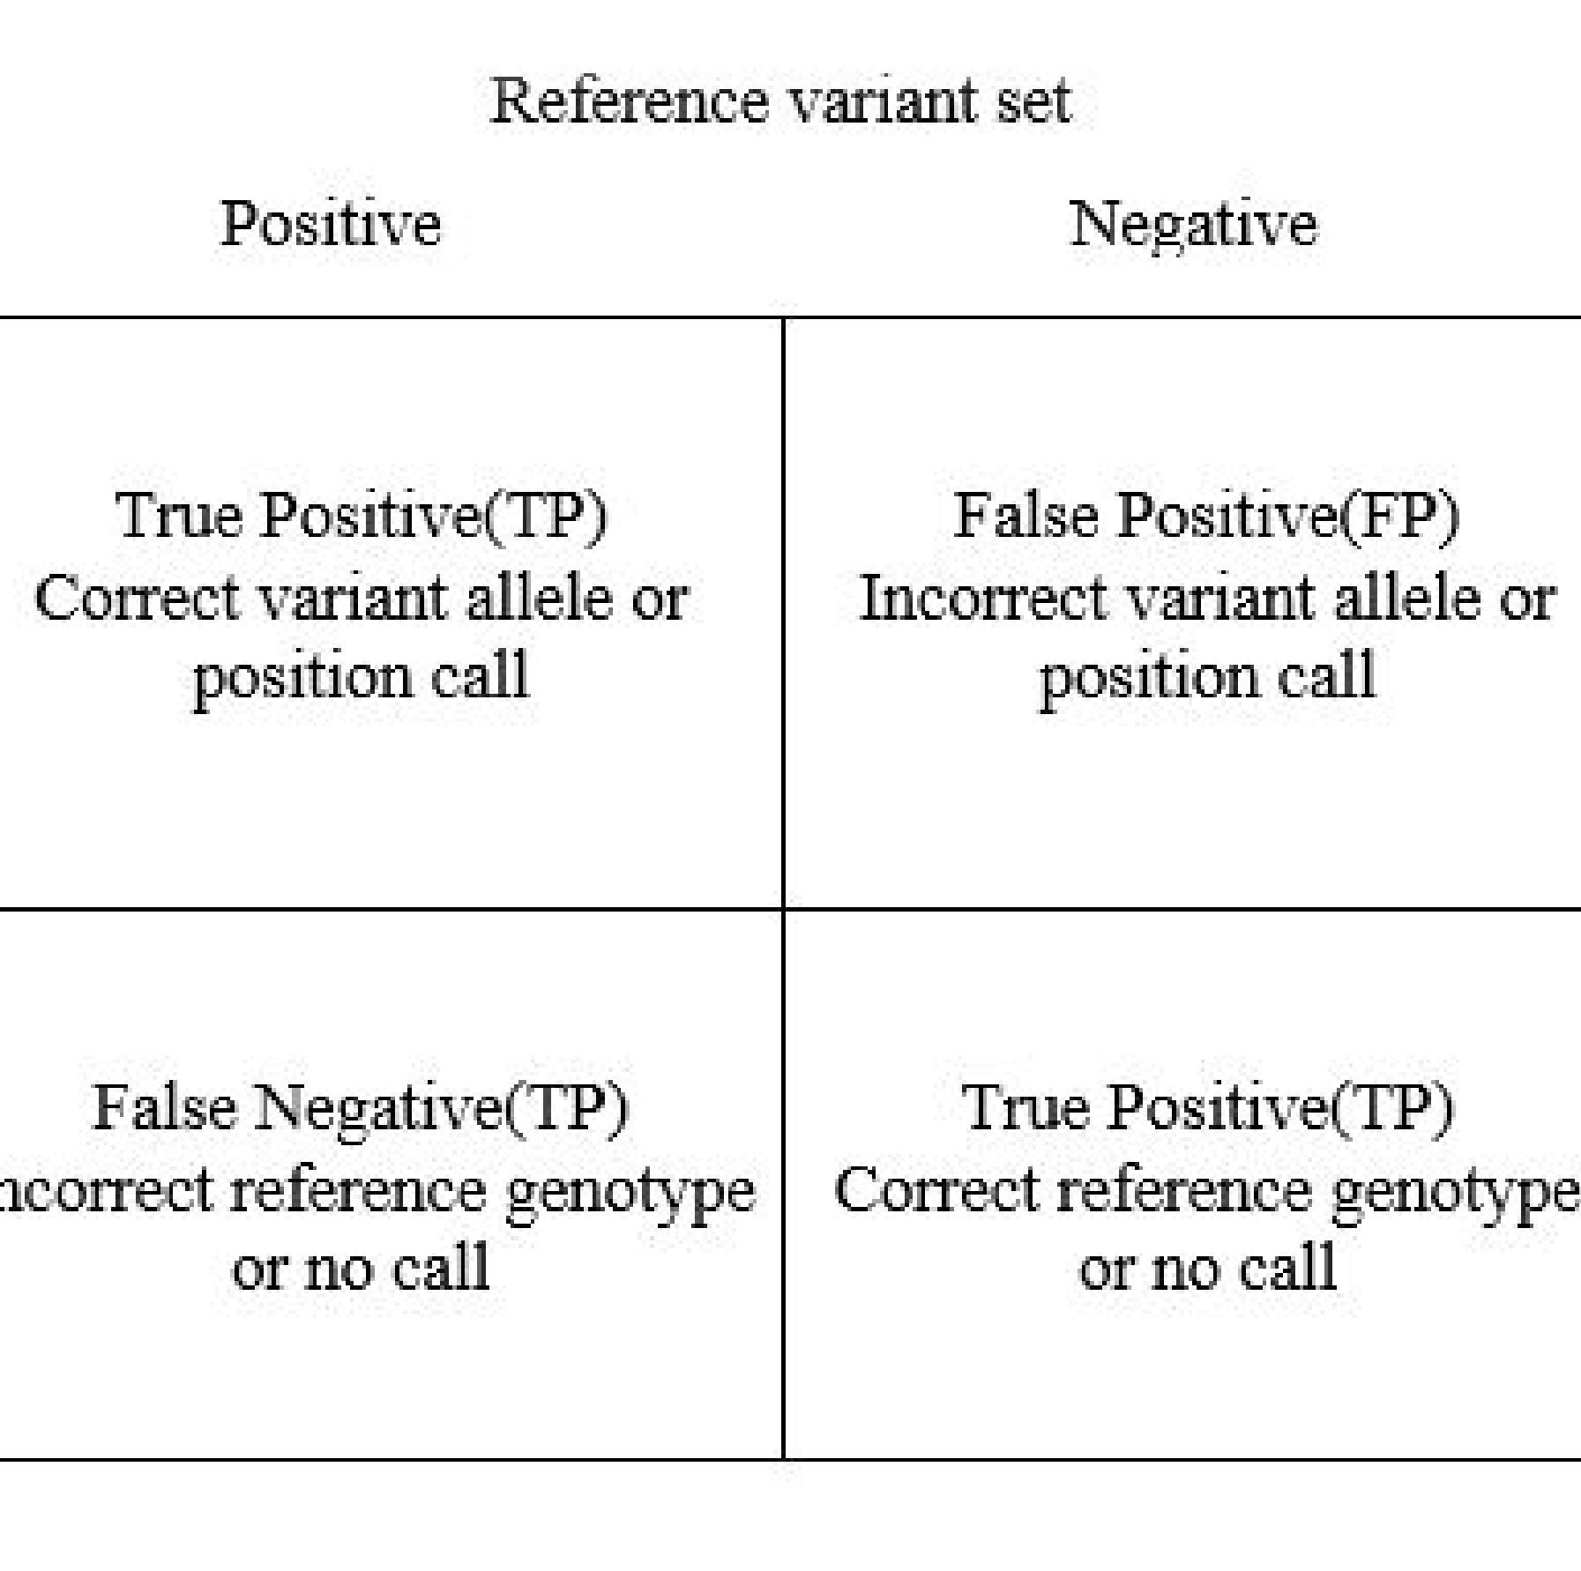

The precision of a test is its capability to distinguish the healthy and unhealthy rice crop leaves correctly. To estimate the precision of a test, we should estimate the distribution of true positive and true negative in all evaluated cases.

***Table 9.2:*** *Result Analysis Table*

|  |  |  |  |  |  |  |
| --- | --- | --- | --- | --- | --- | --- |
| Disease name | No. of Testing  Images | TP | TN | FP | FN | Result |
| Alternaria  Alternata | 10 | 8 | 1 | 1 | 1 | 0.80 |
| Anthracnose | 10 | 9 | 2 | 0 | 0 | 0.91 |
| Bacterial  Blight | 10 | 8 | 1 | 2 | 0 | 0.80 |
| Cercospora  Leaf Spot | 10 | 9 | 1 | 0 | 1 | 0.90 |
| Healthy Leaf | 10 | 8 | 2 | 1 | 0 | 0.81 |

**Average overall accuracy**=0.844=84.4%



## Chapter 10

**USER MANUAL**

Identifying Diseases in Rice Crops using Image Processing User Manual

CHAPTER 10

**USER MANUAL**

The user has two choices to handle the software that is Non-Real Time and Real Time.

* 1. Non-Real Time

The user can access the rice crops present in the trained dataset. The images get loaded into the system. The user later can browse the leaf required for recognition by clicking on browse option. The image gets converted to black and white image by clicking on pre- processing button. Image Processing is an approach to alter a picture into digital form and accomplish processes on it to get an improved picture or take out few effective details from it. The obtained image can later be segmented to R, G and B images by clicking on segmentation button. Image segmentation involves transforming a picture into a group of areas of pixels that are symbolized by a mask or a labelled picture. The features of the image can extract by clicking on the feature extraction button. The selected features are anticipated to hold the appropriate details from the input data; so that the intended work can be done by using this minimized depiction rather than the entire initial data.

In the next step, two algorithms are used that is SVM and K-Means Clustering. The algorithm can later compare the trained dataset with that of the test dataset and the name of the disease in rice crop is obtained.

* 1. Real Time

The user can access the rice crop leaves present in the trained dataset. Firstly, the images get loaded into the system. The user later can capture the image of rice crops by clicking on camera option or can be directly uploaded from gallery. The whole process of pre- processing, segmentation and feature extraction takes place by clicking on respective buttons on the system. The SVM algorithm later compares the trained dataset with that of the test dataset and the name of the disease in rice crop is obtained. Clustering approach lets you design a segmented labelled picture using a distinct clustering algorithm.

Department of CSE, SIT, Mangaluru Page 30



# CONCLUSION AND

**FUTURE WORK**

Identifying Diseases in Rice Crops using Image Processing Conclusion and Future Work

CONCLUSION AND FUTURE WORK

Control, quick and precise disorder finding plays a first-rate position in disease recognition of rice crops. Most of the present image segmentation technique may not have computerized rice crop disease recognition. So recently observed segmentation algorithm, that is k-means clustering will vary the spotted location from backdrop of picture. The result says that an algorithm has made characteristic evaluation easier. It suggests that the preferred technique can find the disorders with a bit computational attempt. The plant disorders may be found at the preliminary level only by this method so that the pest management machines could be utilized to resolve pest problems at the same time by decreasing threats to human and the surroundings.

In Future, there must be a latest technology to draw out the shade through feature evaluation using numerous techniques and then to differentiate the disease sorts from image classification. In order to upgrade disorder recognition proportion at numerous levels, the training specimens may be expanded with the ideal function that has been mentioned as insert circumstance for disorder recognition and fertilization supervision of the crops. Also, the entire procedure defined in this project can be done as an automatic procedure so that the outcome can be conveyed in a completely quick span of time.

Department of CSE, SIT, Mangaluru Page 31



# REFERENCES

REFERENCES

1. Romana Tazeen, Shilpa H N, Usha P, Mrs. Jayanthi M G, Dr. Shashikumar D R, "Image Processing System for Fertilization Management of Crops", *communicated to International Journal of Engineering Research(IJER), 2016.*
2. Al-Hiary, H.S. Bani-Ahmad, M. Reyalat, M. Braik, and Z. AlRahamneh, “Fast and accurate detection and classification of plant diseases”, *International Journal of Computer Applications, 17(1): 31-38, 2011.*
3. Pallavi. S. Marathe, “Plant Disease Detection using Digital Image Processing and GSM”,

*International Journal of Engineering Science and Computing, pp. 10513-15, April 2017.*

1. Vijai Singh, A.K. Misra, “Detection of Plant Leaf Diseases using Image Segmentation and Soft Computing Techniques”, *Information Processing in Agriculture, pp. 41–49, 2017.*
2. Sujatha. R, Y. Sravan Kumar and Garine Uma Akhil, “Leaf Disease Detection using Image Processing”, *Journal of Chemical and Pharmaceutical Sciences, pp 670 – 672, March 2017.*
3. D. Al Bashish, M. Braik, and S. Bani-Ahmad, “A framework for detection and classification of plant leaf and stem diseases", in Signal and Image Processing (ICSIP), *International Conference on. IEEE, pp.113-118, 2010.*
4. J. P. Shah, H. B. Prajapati, and V. K. Dabhi, “A survey on detection and classification of rice plant diseases", *IEEE International Conference on Current Trends in Advanced Computing (ICCTAC), pp. 1-8, March 2016.*
5. Argenti, F.L. Alparone, and G. Benelli, “Fast algorithms for texture analysis using co- occurrence matrices”, *IEEE proceedings, 137, (6): 443-448, 1990.*
6. Barbedo JG, “Digital image processing techniques for detecting, quantifying and classifying plant diseases”, *Springerplus, Vol.2, No.1, pp.660–671, 2013.*
7. Prashant Jain, Jimita Baghel, “Leaf Disease Detection by using K-Means Based Leaves Segmentation”, *Int. Journal of Engineering Research and Application, ISSN: 2248-9622, Issue 3, (Part -5), Vol. 6, March 2016.*



# APPENDIX

APPENDIX







IDENTIFYING DISEASES IN RICE CROPS USING IMAGE PROCESSING

ORIGINALITY REPORT

% 6% % 7%

SIMILARITY INDEX INTERNET SOURCES PUBLICATIONS STUDENT PAPERS

PRIMARY SOURCES

www.int-arch-photogramm-remote-sens-spatiaI- inf-sci.net

2%

Internet Source

#### Submitted to The American International School of Vienna

o

O

Student Paper

#### Submitted to Charotar University Technology

Student Paper

##### ijireeice.com

Internet Source

### of Science And

%

O o

### Submitted to Bharati Vidyapeeth Deemed

#### University College Of Engineering

Student Paper

##### Submitted to R V College of

Student Paper

Engineering • %

[WWW.Sprin](http://WWW.Sprin/)

Internet Source

##### er rofessionaI.de

ncct-matlabprojects.bIogspot.com

Internet Source

###### [www.kscst.iisc.ernet.in](http://www.kscst.iisc.ernet.in/)

Internet Source

##### biomisa.org

Internet Source

### Submitted to Shri Guru Gobind Singhji of Engineering and Technology

Student Paper

##### Submitted to University of Ulster

Student Paper

##### id.scribd.com

Internet Source

##### Submitted to Study Group Australia

Student Paper

##### Institute

O o

O o



" * %

O o



O o

"Study on Expansion of Crack in RCC Beam by Using DIC — MATLAB", International Journal of Engineering Research and Advanced Technology, 2017

o

O

Publication

##### heroturko.cz

Internet Source

##### Junde Chen, Defu Zhang, Y.A. Nanehkaran, Dele Li. "Detection of rice plant diseases based

on deep transfer learning", Journal of the Science of Food and Agriculture, 2020

Publication

###### [www.ijitr.com](http://www.ijitr.com/)

Internet Source

###### Submitted to Visvesvaraya Technological

O o

###### University

Student Paper

###### snapcrack.net

Internet Source

###### Prabira Kumar Sethy, Nalini Kanta Barpanda,

O

###### Amiya Kumar Rath, Santi Kumari Behera. O

"Image Processing Techniques for Diagnosing Rice Plant Disease: A Survey", Procedia Computer Science, 2020

Publication

###### Submitted to National College of Ireland

Student Paper

#### Submitted to University of Central

Student Paper

###### Lancashire 0 o

Submitted to The Hong Kong Polytechnic

O o

###### University

Student Paper

###### Submitted to Liverpool John Moores University

Student Paper ONO

preview-jwcn-eurasipjournaIs.sprin

e r O

e n CO

Internet Source

#### docpIayer.net

Internet Source

g p ” " %

O o

#### bmcbioinformatics.biomedcentraI.com

Internet Source

#### Submitted to Cranfield University

O

Student Paper O

#### Submitted to University of London External System

o

O

Student Paper

#### Antonio J. M. Ferreira, Nicholas Fantuzzi. "MATLAB Codes for Finite Element Analysis", Springer Science and Business Media LLC, 2020

Publication

#### Submitted to West Linn High School

Student Paper

#### Submitted to Edith Cowan University

O

o

Student Paper

#### Submitted to Caledonian College of Engineering

Student Paper ONO

V. K. Shrivastava, M. K. Pradhan, S. Minz, M. Thakur. "RICE PLANT DISEASE

P. * %

#### CLASSIFICATION USING TRANSFER LEARNING OF DEEP CONVOLUTION

NEURAL NETWORK", ISPRS - International Archives of the Photogrammetry, Remote Sensing and Spatial Information Sciences, 2019

Publication

#### Susmita Dey, Ripon Sarkar, Kabita Chatterjee,

O

o

#### Pallab Datta, Ananya Barui, Santi P. Maity.

"Pre-cancer risk assessment in habitual smokers from DIC images of oral exfoliative cells using active contour and SVM analysis", Tissue and Cell, 2017

Publication

Exclude quotes On Exclude bibliography On

Exclude matches Off